Title: Read About The UPSC Management Syllabus For UPSC 2019 Prelims And Optional Papers
Desc: Know more about the IAS Management Syllabus and Download UPSC Management Syllabus PDF to speed up IAS preparation for IAS 2019.

UPSC Management Syllabus
Download UPSC Management Syllabus PDF

UPSC Civil Services Mains Exam has Management as one of the Optional Subjects with 2 papers (Optional Paper I and Paper II). This article provides you with the UPSC Management syllabus for Optionals.

Management one part of the syllabus that stays relevant for the aspirant even after clearing the UPSC Exam. This is because it is an integral part of an IAS officers job. Management knowledge gained during IAS preparation remains useful in every area of work and not just during the IAS exam. Candidates who have completed degrees in management, or are working as managers would find it an ideal optional subject.

UPSC Management Optional Syllabus

Each paper is of 250 marks with a total of 500 marks.

UPSC Management Optional Syllabus for Paper I:

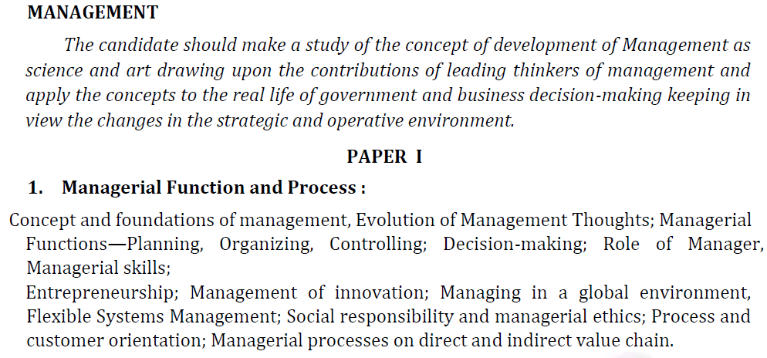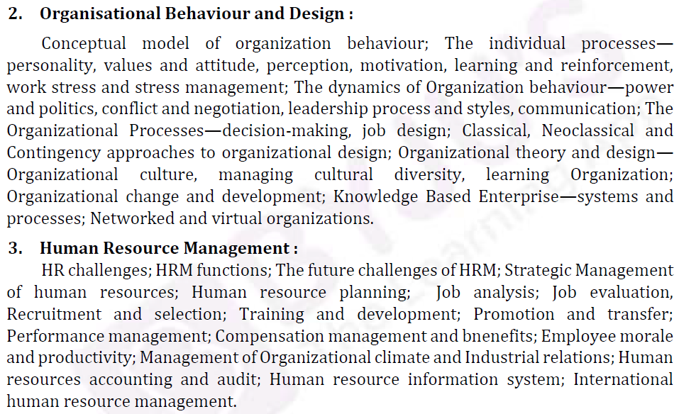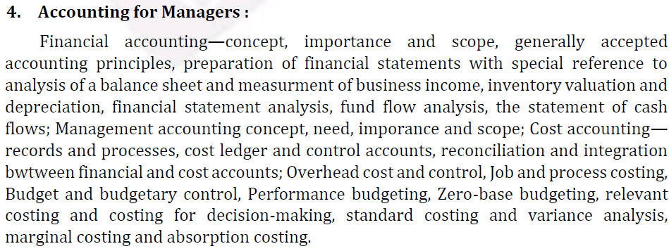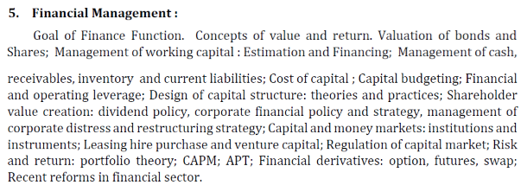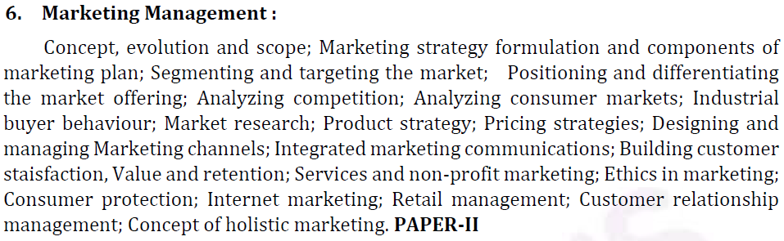

UPSC Management Optional Syllabus for Paper II:
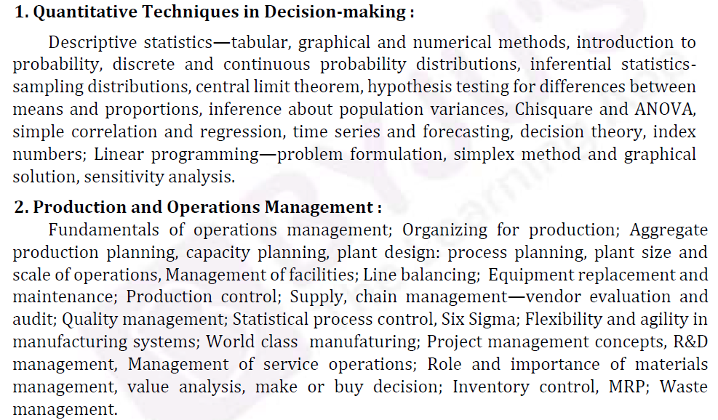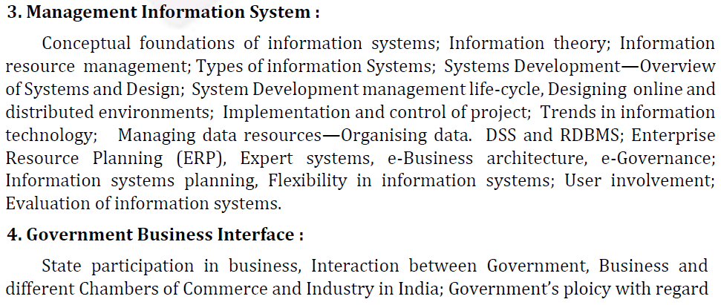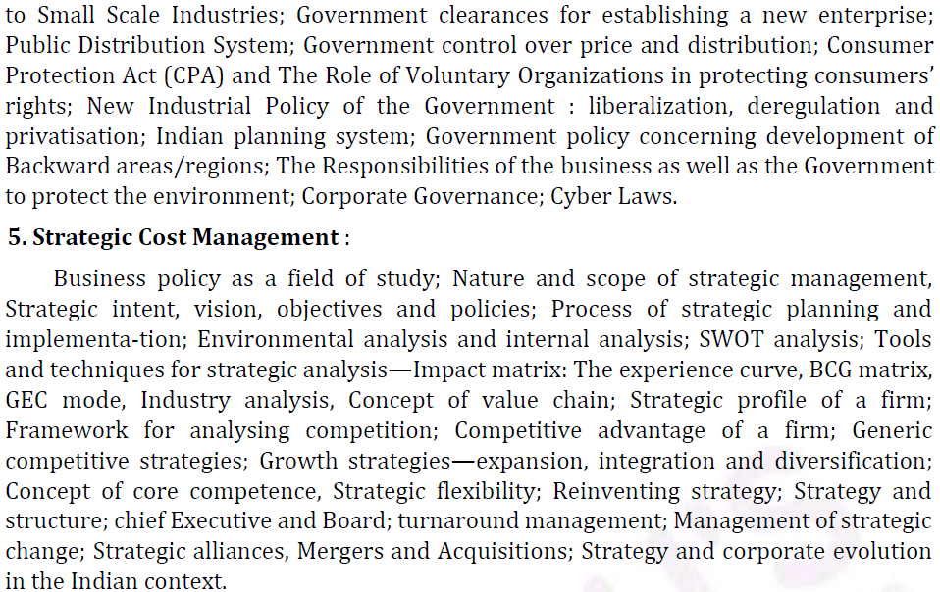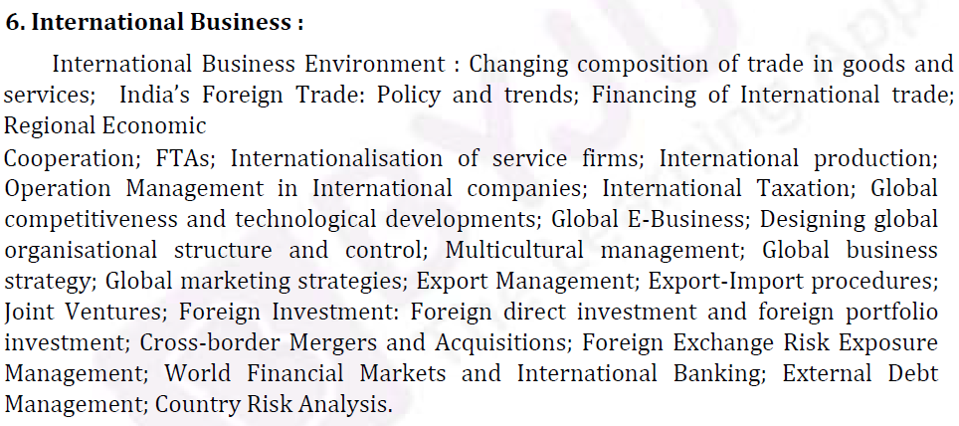

IAS aspirants should note that for Management, preparation should be thorough as the concepts learnt will be useful during training and afterwards. Also, candidates should solve more questions from previous years’ UPSC question papers as well as participate in mock tests for preparation.

Download UPSC Management Syllabus PDF

To read more on UPSC preparation please visit:

Related Links:
UPSC Prelims | UPSC Books
UPSC Mains | UPSC 2019
NCERT Books for UPSC | UPSC Syllabus
Strategy for Management Optional for UPSC | Management Optional
Most Scoring Optional Subjects | Most Popular Optional Subjects
How to Choose an Optional Subject | IAS Anthropology Syllabus

