- Which of the following amine will be prepared by Gabriel phthalimide reaction?
1) n-Butylamine 2) Triethylamine 3) neo-Pentylamine 4) tert-Butylamine
Solution:
(1)
Gabriel pthalimide synthesis is used to prepare 1⁰ amines only
- Reaction of dilute HCl with Maltose gives:
1) D – glucose 2) D – fructose 3) D – glucose and D – fructose 4) D – galactose
Solution:
(1)
Maltose is a dissacalaride, consisting of 2 glucose units. So on hydrolysis, it give only D-glucose.
- The correct order of K_{b} value of following is
1) 1 > 2 > 3 2) 1 > 3 > 2 3) 3 > 2 > 1 4) 3 > 1 > 2
Solution:
(2)
kb α Basic strength.
Basic strength α amount of hydration α Availability of Lone Pairs on Nitrogen.
Combining both effects, the order of Basic strength is, 2⁰ > 3⁰ > NH₃
- Write IUPAC name of the following compound
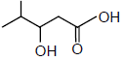
1) 3-Hydroxy-2-methylpentanoic acid 2) 4-Methyl-3-hydroxypentanoic acid
3) 3-Hydroxy-4-methylpentanoic acid 4) 2-Methyl-2-hydroxypentanoic acid
Solution:
(3)
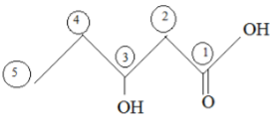
3-hydroxy 4-methyl Pentanoic acid
- Compound ‘X’ will be
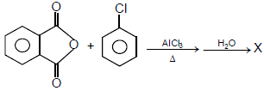
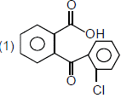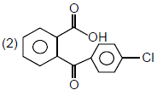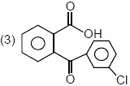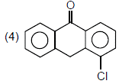
Solution:
(2)
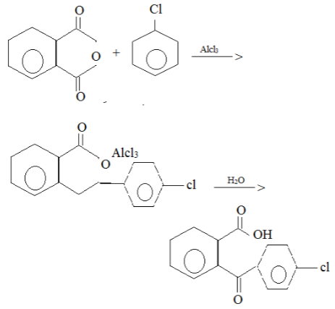
- X will be:
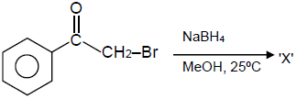
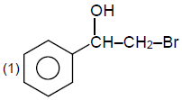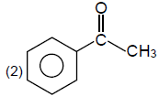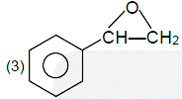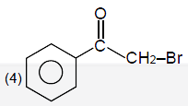
Solution:
(3)
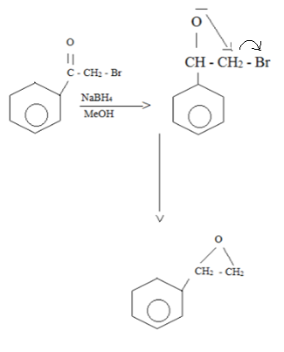
- 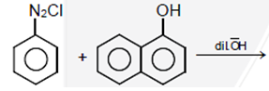
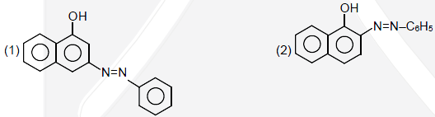
Solution:
(3)
In a2o coupling reaction, the Hydrogen is taken from the less hindered para position.
- 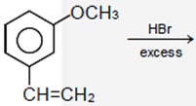
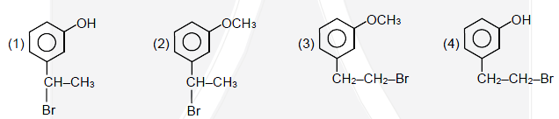
Solution:
(1)
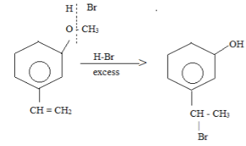
Two reaction occur simultaneously
1) Ether hydrolysis using HBr
b) Electrophilic addition of H-Br
- Find the compound ‘X’ which give following test.
Neutral FeCl₃ → -ve
Fehling solution → -ve
Iodoform reaction → +ve
Grignard reagent → +ve
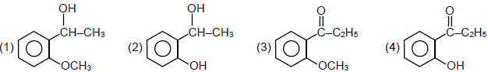
Solution:
(1)
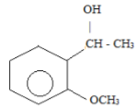
Neutre Fecl₃ → - ve (phenol is absent)
Fehling test → - ve (no CHO)
Iodoform → + ve (α – Methyl group is present)
Grignard → acidic H-atom is present
- Identify the compound ‘X’
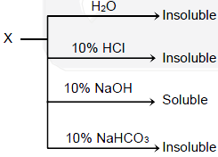
1) Toluidine 2) Benzamide 3) Para-Cresol 4) Oleic acid
Solution:
(3)
Para-cresol is acidic enough to be soluble in 10% NaOH. But Oleic acid forms salt, but is insoluble due to presence & long chain of Hydrocarbon
- Which of the following is not correct for an ideal gas as per first low of thermodynamics
1) Adiabatic ΔU = -w 2) Isothermal q = -w 3) cyclic q = -w 4) Isochoric ΔU = q
Solution:
(1)
From 1st Law,
∆U = q + ω
In adiabatic, q = 0
[latex]\therefore[/latex] ∆U = ω
- In Freundlich isotherm, [latex]\frac{x}{m}\propto {{P}^{a}}.[/latex] Find the value of a from the following graph
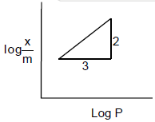
1) [latex]\frac{2}{3}[/latex] 2) [latex]\frac{1}{3}[/latex] 3) [latex]\frac{3}{2}[/latex] 4) 1
Solution:
(1)
Freundlich Isotherm equations:
[latex]\log \frac{x}{m}=\log k+\frac{1}{n}\log P[/latex]
[latex]y\,\,\,\,\,\,\,\,\,\,\,=\,c+mx[/latex]
[latex]herem\,\,\,\,\,\,\,\,\,\,=\frac{1}{n}=\frac{2}{3}[/latex].
- In a mixture of A and B having vapour pressure of pure A and pure B are 400 mm Hg and 600 mm Hg respectively, mole fraction of B in liquid phase is 0.5. Calculate total vapour pressure and mole fraction of A and B in vapour phase
1) 500, 0.4, 0.6 2) 500, 0.5, 0.5 3) 450, 0.4, 0.6 4) 450, 0.5, 0.5
Solution:
(1)
[latex]{{P}_{T}}=P\,_{A\times A}^{o}+P\,_{B\times B}^{o}[/latex]
= 0. 5 × 400 + 0.5 × 600
= 500 mm of Hg
[latex]\frac{1}{{{P}_{T}}}=\frac{{{Y}_{A}}}{400}+\frac{1-{{Y}_{B}}}{600}[/latex]
[latex]\therefore {{Y}_{A}}=0.6[/latex]
[latex]{{Y}_{B}}=1-0.6=0.4[/latex]
- Arrange the following set of quantum numbers having highest energy of an electron.
(p) n = 4 l = 1 m = +1 s = [latex]+\frac{1}{2}[/latex]
(q) n = 4 l = 2 m = -1 s [latex]=-\frac{1}{2}[/latex]
(r) n = 3 l = 2 m = 0 s [latex]=+\frac{1}{2}[/latex]
(s) n = 3 l = 1 m + 1 s [latex]=-\frac{1}{2}[/latex]
1) q > r > p > s 2) q > p > r > s 3) s > p > r > q 4) s > r > p > q
Solution:
(2)
[latex]E\,\alpha \,\left( n+l \right)[/latex]
- A forms ccp lattice, B occupy half of the octahedral voids and ‘O’ occupy all the tetrahedral voids. Calculate formula –
1) A₂BO₄ 2) ABO₄ 3) A₂B₂O 4) A₂B₂O
Solution:
(1)
CCP lattice of A → no of atom of A per unit cell → 4.
N oct. voids = 2 N tetra. Voids. But B occupies only half of oct. voids
[latex]\therefore[/latex] No of atoms of B = [latex]4\times \frac{1}{2}=2[/latex]
No of atoms of C → 4 × 2 = 8
[latex]\therefore[/latex] The formula → A₄ B₂ C₈
- B₂H₆ reacts with O₂ and H₂O respectively to form
1) B₂O₃, H₃BO₃ 2) [latex]{{B}_{2}}{{O}_{3}},B{{H}_{{{4}^{-}}}}[/latex] 3) HBO₂, H₃BO₃ 4) H₃BO₃, HBO₂
Solution:
(1)
B₂H₆ reacts with O₂ and H₂O to form Diborane extensively burns in oxygen to form basic oxide and B₂H₆ hydrolysis to give Boric acid
[latex]{{B}_{2}}{{H}_{6}}+3{{O}_{2}}\to {{B}_{2}}{{O}_{3}}+3{{H}_{2}}O[/latex]
[latex]{{B}_{2}}{{H}_{6}}+6{{H}_{ & 2}}O\to 2{{H}_{3}}B{{O}_{3}}+3{{H}_{2}}[/latex]
- Solution of 100 ml water contains 0.73 g of Mg(HCO₃)₂ and 0.81 g of Ca(HCO₃)₂. Calculate the hardness in terms of ppm of CaCO₃.
1) 10² ppm 2) 10⁴ ppm 3) 5 × 10³ ppm 4) 10³ ppm
Solution:
(2)
Number of moles of[latex]Mg{{\left( HC{{O}_{3}} \right)}_{2}}=\frac{0.73}{146}=0.005[/latex]
Number of moles of[latex]Ca{{\left( HC{{O}_{3}} \right)}_{2}}=\frac{0.81}{162}=0.005[/latex]
[latex]PPM=\frac{Total\,no.of\,mole\times 100\times {{10}^{6}}}{100}[/latex]
[latex]=\frac{0.005+0.005\times 100\times {{10}^{6}}}{100}[/latex]
[latex]={{10}^{4}}PPM[/latex].
- For [latex]Z{{r}_{3}}{{(P{{O}_{4}})}_{4}}[/latex] the solubility product is K_{sp} and solubility is S. Find the correct relation.
1) [latex]S={{\left( \frac{{{K}_{sp}}}{6912} \right)}^{1/7}}[/latex] 2) [latex]S={{\left( \frac{{{K}_{sp}}}{216} \right)}^{1/7}}[/latex] 3) [latex]S={{\left( \frac{{{K}_{sp}}}{216} \right)}^{1/8}}[/latex] 4) [latex]S={{\left( \frac{{{K}_{sp}}}{912} \right)}^{1/3}}[/latex]
Solution:
(1)
It is A₃B₄ type of salt
Hence[latex]K{{s}_{p}}={{\left( 3s \right)}^{3}}\times {{\left( 4s \right)}^{4}}[/latex]
[latex]\,\,\,\,\,\,\,\,\,=27{{s}^{3}}\times 256{{s}^{4}}[/latex]
[latex]K{{s}_{p}}=6912{{s}^{7}}[/latex]
[latex]S\,\,\,\,\,=\sqrt[7]{\frac{K{{s}_{P}}}{6912}}[/latex]
- Given complexes are low spin complexes,
[latex]{{[V{{(CN)}_{6}}]}^{4-}}[/latex]
[latex]{{[Cr{{(N{{H}_{3}})}_{6}}]}^{2+}}[/latex]
[latex]{{[Ru{{(N{{H}_{3}})}_{6}}]}^{3+}}[/latex]
[latex]{{[Fe{{(CN)}_{6}}]}^{4-}}[/latex]
Then order of magnetic moment (μ) for [latex]{{V}^{2+}},F{{e}^{2+}},C{{r}^{+3}},R{{u}^{3+}}[/latex] is
1) [latex]{{V}^{2+}}>C{{r}^{2+}}>F{{e}^{2+}}>R{{u}^{3+}}[/latex] 2) [latex]F{{e}^{2+}}>{{V}^{2+}}>C{{r}^{+2}}>R{{u}^{3+}}[/latex]
3) [latex]{{V}^{2+}}>C{{r}^{2+}}>R{{u}^{3+}}>F{{e}^{2+}}[/latex] 4) [latex]F{{e}^{2+}}>C{{r}^{3+}}>{{V}^{2+}}>R{{u}^{3+}}[/latex]
Solution:
(3)
For[latex]{{\left[ V{{\left( CN \right)}_{6}} \right]}^{-4}}[/latex]
Magnetic moment[latex]=\sqrt{3\left( 3+2 \right)}=\sqrt{15}BM=3.9BM[/latex]
[latex]{{\left[ Cl{{\left( N{{H}_{3}} \right)}_{6}} \right]}^{2+}}[/latex]
Magnetic moment[latex]=\sqrt{2\left( 2+2 \right)}=\sqrt{8}=2.9BM[/latex]
[latex]{{\left[ Ru{{\left( N{{H}_{3}} \right)}_{6}} \right]}^{+3}}[/latex]
Magnetic moment[latex]=\sqrt{1\left( 1+2 \right)}=\sqrt{3}=1.732[/latex]
[latex]{{\left[ Fe{{\left( CN \right)}_{6}} \right]}^{-4}}[/latex]
Magnetic moment =[latex]\sqrt{no\,\,unpaired}=0[/latex]
Hence order[latex]{{V}^{+2}}>C{{l}^{+2}}R{{u}^{+3}}>F{{e}^{+2}}[/latex]
- Given [latex]E{{{}^\circ }_{{{S}_{2}}O_{8}^{2-}/SO_{4}^{2-}}}=2.05V[/latex]
[latex]E_{B{{r}_{2}}/B{{r}^{-}}}^{o}=1.40V[/latex]
[latex]E_{A{{u}^{3+}}/Au}^{o}=1.10V[/latex]
[latex]E_{{{O}_{2}}/{{H}_{2}}O}^{o}=1.20V[/latex]
Which of the following is the strongest oxidizing agent?
1) [latex]{{S}_{2}}O_{8}^{2-}[/latex] 2) Br₂ 3) Au⁺³ 4) O₂
Solution:
(1)
More is Positive standard reduction Potential more is oxidizing nature hence[latex]{{S}_{2}}O_{8}^{-2}[/latex]is answer (1)
- Assertion: Ozone is getting depleted due to CFCs
Reason: With the deplection of ozone layer more UV radiation filters into troposphere
1) Both Assertion and Reason are true and Reason is the correct explanation of Assertion.
2) Both Assertion and Reason are true but Reason is not correct explanation of Assertion.
3) Assertion is true but Reason is false.
4) Assertion is false but Reason is true.
Solution:
(2)
Ozone gets decomposed by CFCS hence Assertion is correct
Ozone depletion cause, harmful uv rays to enter troposphere hence reason is correct but reason is not correct explanation of assertion, [2]
- In which of the following order of hydration energy correct.
1) [latex]L{{i}^{+}}>N{{a}^{+}}>{{K}^{+}}>R{{b}^{+}}>C{{s}^{+}}[/latex] 2) [latex]L{{i}^{+}}<N{{a}^{+}}<{{K}^{+}}<R{{b}^{+}}<C{{s}^{+}}[/latex]
3) [latex]L{{i}^{+}}>N{{a}^{+}}>{{K}^{+}}>C{{s}^{+}}>R{{b}^{+}}[/latex] 4) [latex]L{{i}^{+}}<N{{a}^{+}}<{{K}^{+}}<C{{s}^{+}}<R{{b}^{+}}[/latex]
Solution:
(1)
Hydration energy α charge
[latex]\alpha \frac{1}{size}[/latex]
[latex]\therefore[/latex] [latex]L{{i}^{+}}>N{{a}^{+}}>{{K}^{+}}>R{{b}^{+}}>C{{s}^{+}}[/latex]
- Ellingham diagram is used for
1) Reduction 2) Electrolysis 3) Zone refining 4) Van-Arkel
Solution:
(1)
It is used for estimating, the temperature at which a particular metal oxide is reduced by another metal.
- In isoelectronic species [latex]C{{l}^{-}},Ar,C{{a}^{2+}}[/latex] size differ due to
1) Nuclear charge 2) Electronic – electronic repulsion in valence shell
3) Magnetic quantum number 4) Principal quantum number
Solution:
(1)
Isoelectronic species differ in size only due to difference in Nuclear change.
- 3 mole of Ag is heated from 300 K to 1000 K. Calculate ΔH when P = 1 atm and C_{P} = 23 + 0.01 T.
1) 62 kJ/mol 2) 45 kJ/mol 3) 38 kJ/mol 4) 54 kJ/mol
Solution:
(1)
[latex]\Delta H=\int\limits_{{{T}_{1}}}^{{{T}_{2}}}{n\,CpdT}[/latex]
[latex]n\int\limits_{30}^{400}{\left( 23+0.1T \right)dT}[/latex]
[latex]=3\left[ 23T+\frac{{{0.17}^{2}}}{2} \right]_{300}^{400}[/latex]
[latex]=61960J/mol\Rightarrow 62k{}^\circ mol[/latex]
- [latex]Fe{{C}_{2}}{{O}_{4}},F{{e}_{2}}{{({{C}_{2}}{{O}_{4}})}_{3}},FeS{{O}_{4}},F{{e}_{2}}{{(S{{O}_{4}})}_{3}}[/latex] one mole each, will react with how many moles of [latex]KMn{{O}_{4}}[/latex]
1) 1 2) 2 3) 3 4) 5
Solution:
(2)
[latex]Fe{{C}_{2}}{{O}_{4}}+KMn{{O}_{4}}\xrightarrow{{}}F{{e}^{3+}}+C{{o}_{2}}+M{{n}^{2+}}[/latex]
[latex]F{{e}_{2}}{{\left( {{C}_{2}}{{O}_{4}} \right)}_{3}}+MnO_{4}^{-}\xrightarrow{{}}F{{e}^{3+}}[/latex]
[latex]F{{e}_{3}}{{O}_{4}}\xrightarrow{{}}F{{e}^{3+}}[/latex]
[latex]\therefore[/latex] Total: [latex]\frac{3}{3}+\frac{6}{5}+\frac{1}{5}=2[/latex]
- For 2A + B → C. Find the rate low.
[A] | [B] | Initial Rate
0.05 | 0.05 | 0.045
0.10 | 0.05 | 0.09
0.20 | 0.10 | 0.72

1) R = K[A] [B] 2) R = k[A] [B]² 3) R = k[A²][B] 4) R = k[A]² [B]²
Solution:
(2)
[latex]{{v}_{1}}=K{{\left[ {{A}_{1}} \right]}^{x}}{{\left[ B \right]}^{4}}[/latex]
[latex]\frac{{{v}_{2}}}{{{r}_{1}}}=\frac{\cancel{0.09}}{\cancel{0.045}}={{\left( \frac{\cancel{0.1}}{\cancel{0.05}} \right)}^{x}}[/latex]
[latex]2={{2}^{x}}[/latex]
[latex]x=1[/latex].
[latex]\frac{0.79}{0.09}={{\left( \frac{0.2}{0.1} \right)}^{1}}{{\left[ \frac{0.1}{0.05} \right]}^{4}}[/latex]
[latex]8={{2}^{1}}{{2}^{y}}[/latex]
[latex]{{2}^{y}}=4[/latex]
[latex]y=2[/latex]
- Which of the following lanthanoid ions are coloured?
(a) Lu⁺³ (b) Pm⁺³ (c) Sm⁺³ (d) Eu⁺³
1) [latex]L{{u}^{+3}},P{{m}^{+3}},S{{m}^{+3}}[/latex] 2) [latex]P{{m}^{+3}},S{{m}^{+3}},E{{u}^{+3}}[/latex] 3) [latex]L{{u}^{+3}},P{{m}^{+3}},S{{n}^{+3}}[/latex] 4) [latex]L{{u}^{+3}},S{{m}^{+3}},E{{u}^{+3}}[/latex]
Solution:
(2)
[latex]P{{m}^{+3}},S{{m}^{+7}},E{{u}^{+7}}[/latex] contain unpaired [latex]f-[/latex] electrons hence coloured.

